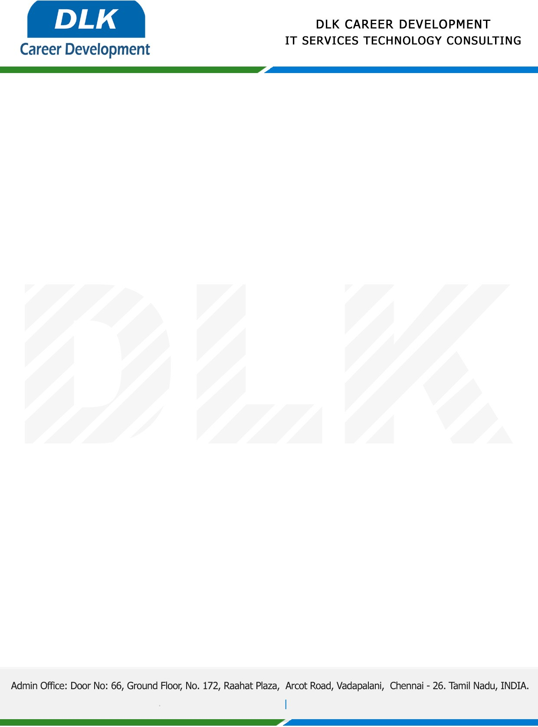

Date: 31 /December / 2022

**To**

Department of MBA ([Human Resource & Finance),](https://www.cseindia.org/)

Head of Department,

Sathyabama Institute of Science and Technology, Chennai - 600119.

**Sub: Letter of Project Acceptance**

This is to certify that **MS PRAGATHI A (REG NO: 41410228)** that final year student of has accepted her Project Work duration from **02nd January 2023** to **31st March 2023** under the domain **“Human Resource”.** During the internship, all information and data collected from you should be kept confidential.

**Topic:** Performance Appraisal of Employee Performance in an Organisation.

We appreciate your interest in **DLK CAREER DEVELOPMENT**

